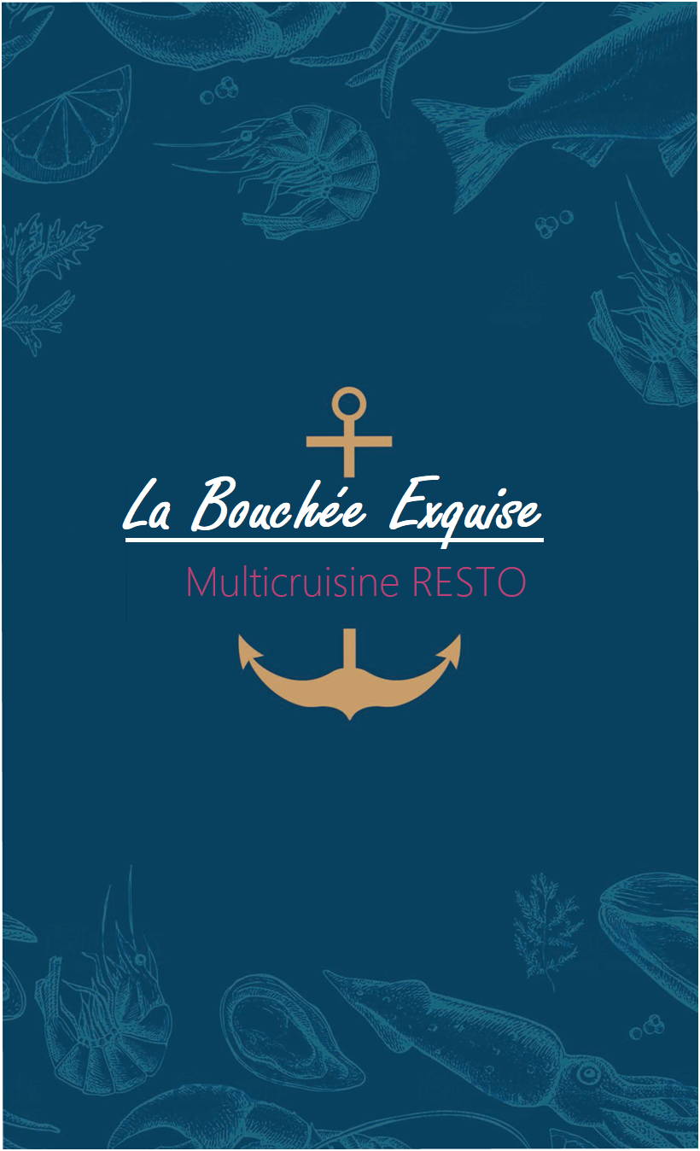

Seared Ahi Tuna Fried Pickles



Gulf Shrimp Cocktail Chips & Guacamole Shrimp Ceviche

Tres Dips • *queso, guacamole and salsa*

Queso

# STARTERS

$12.99

$4.99

$8.99

$7.99

$8.99

$10.49

$4.99 *with beef* $5.99

Shrimp Brochette • *bacon wrapped gulf shrimp stuffed with jalapeños and cream cheese*

Crab Cake

U-Peel-Em Shrimp

BAHNditos • *choice of chicken or shrimp, Monterrey jack and cheddar cheese, peppers and onions, wrapped in a flour tortilla, deep fried* • *served with chipotle ranch dressing*

$11.99

$9.99

*½ lb.* $10.99 *1lb.* $18.99

*Chicken* $6.99 *Shrimp* $7.99

Nachos *Bean & Cheese* $6.49 *Chicken or Ground Beef* $8.99 *Ahi Tuna* $14.99 Quesadilla *Spinach & Mushroom* $6.99 *Beef or Chicken* $8.99

|  |  |  |
| --- | --- | --- |
| Buffalo Wings • *traditional or boneless* • *Thai sweet chili, bbq, buffalo,sweet red chili bbq, lemon pepper* Appetizer Platter • *¼ lb. U-Peel-Em Shrimp, 1 Chicken Quesadilla, 4oz. Ceviche* • *served with chips and salsa* Loaded Potato Skins | *10 Piece* $9.99 | *20 Piece* $17.99  $18.99  $5.99 |
| **SOUPS & SALADS** |  |  |

Creamy Poblano Corn Chowder or Chicken Tortilla Soup Greek Shrimp Salad



Chicken Caesar Salad Seared Ahi Tuna Salad

All You Can Eat Salad Bar with Soup Haus Grilled Chicken Salad



*Cup* $2.99 *Bowl* $4.99

$11.99 *with Chicken* $9.99

*with Grilled or Blackened Chicken* $10.49

$14.99

$8.99

$9.99

|  |  |
| --- | --- |
| Cobb Salad • *blackened chicken sliced ham, bacon, cheese, tomato, red onion, egg and avocado* | $11.99 |
| Chef Salad • *sliced turkey, ham, bacon, cheese, tomato, red onion and egg* | $8.99 |
| Side Salad or Caesar Side Salad | $2.49 |
| **SANDWICHES & TACOS** |  |
| Served with your choice of Steak Fries, Onion Rings or Hushpuppies. Substitute Salad Bar for $3.99. | |
| Chicken Sandwich • *buffalo, blackened, grilled or fried* • *served with Swiss cheese, lettuce, tomato and onion* | $9.49 |
| California Chicken Club Sandwich • *served with swiss cheese, lettuce, tomato, avocado and bacon* | $10.49 |
| Cheeseburger • *served with lettuce, tomato, onions and a pickle spear* | $8.49 |
| Bacon Cheeseburger • *served with lettuce, tomato, onions and a pickle spear* | $9.49 |
| Southwest Burger • *topped with queso, pico de gallo, fried jalapeño and sliced avocado* | $11.99 |

Fish or Shrimp Tacos • *seasoned fish or shrimp served on a soft corn tortilla topped* $10.99 *with Mahi Mahi* $12.99

*with shredded cabbage, pico de gallo, sliced avocado and remoulade sauce*

Clubhouse Sandwich • *lettuce, tomato, bacon, turkey and ham* $8.99

#### House Speciality

Consuming raw or undercooked meats, poultry, seafood, shellfish or eggs may increase your risk of foodborne illness, especially if you have certain medical conditions. Please be advised that food prepared here may contain milk, eggs, wheat, soybean, peanuts, treenuts, fish and shellfish. Please notify management with any allergies.



# SHRIMP ENTREES



Cajun Shrimp Pasta • *gulf shrimp served over linguine tossed in a creamy cajun sauce* • *served with garlic bread* $15.99 Tropical Island Shrimp • *sweet and spicy gulf shrimp paired with grilled pineapple and mango* $16.99 Coconut Fried Shrimp • *gulf shrimp hand breaded in a mixture of roasted coconut and panko bread crumbs,* $16.99 *deep fried and served with orange marmalade*

Fried Shrimp • *lightly battered and fried to a golden brown* $15.99

Grilled Shrimp • *gulf shrimp seasoned to perfection and served with lemon garlic butter* $15.99

Blackened Shrimp • *shrimp blackened with herbs and spices* $15.99

Shrimp Brochette • *bacon wrapped gulf shrimp stuffed with jalapeños and cream cheese* $16.99

Shrimp Trio • *two shrimp brochettes, four fried shrimp and two coconut shrimp* $19.99 Baked Stuffed Shrimp • *gulf shrimp filled with a blend of crabmeat stuffing, drizzled with lemon garlic butter* $19.95 Shrimp Alfredo • *grilled shrimp served over linguine tossed in our homemade Alfredo sauce* • *served with garlic bread* $15.99

# STEAK/CHICKEN/FISH ENTREES



Ask server about accompanying sides.

Mushroom Smothered Chicken • *chicken breast smothered in a mushroom gravy* $11.99 Red Drum Pontchartrain • *blackened and topped with a creamy Cajun sauce with scallops, crawfish, crab and shrimp* $22.99 10oz. Ribeye • *seasoned and grilled to perfection* $20.99

Mahi Mahi • *grilled or blackened* • *topped with lemon caper cream sauce* $21.99

Chicken Fried Steak • *hand breaded country fried steak, topped with homemade cream gravy* $10.99 Chopped Beef Steak • *10 oz. chopped steak topped with mushroom gravy* • *served with garlic mashed potatoes and green beans* $12.99 Chicken Fried Chicken • *hand breaded chicken breast, topped with homemade cream gravy* $9.99 Chicken Alfredo • *grilled chicken served over linguine, tossed in our homemade Alfredo sauce* • *served with garlic bread* $11.99

# SIDES



Jasmine Rice • Garlic Mashed Potatoes • Steak Fries • Macaroni & Cheese • Hushpuppies $2.49 Onion Rings • Green Beans • Chef’s Vegetables • Side Salad • Sweet Corn

**Substitute Salad Bar $3.99**

# ADD ONS



**Your Choice of:**

*5 Grilled, Fried or Blackened Shrimp • 2 Shrimp Brochette • 2 Baked Crab Stuffed Shrimp* **$6.99**

#### House Speciality

Consuming raw or undercooked meats, poultry, seafood, shellfish or eggs may increase your risk of foodborne illness, especially if you have certain medical conditions. Please be advised that food prepared here may contain milk, eggs, wheat, soybean, peanuts, treenuts, fish and shellfish. Please notify management with any allergies.

# HAUS BASKETS



Served with your choice of steak fries, onion rings or hushpuppies.

Fried Shrimp $9.99

Fried Oysters $9.99

Fried Fish $8.99

Combo Basket *Any Two* $9.99 *All Three* $10.99

# PIZZA



|  |  |
| --- | --- |
| *8 in* $6.99 | 16 *in* $12.99 |
| *8 in* $10.99 | 16 *in* $15.99 |
| *8 in* $11.99 | 16 *in* $17.99 |

Cheese Pizza

Supreme Pizza • *pepperoni, Italian sausage, ham, onions, bell pepper, black olives and mushrooms*

Meat Wave Pizza • *pepperoni, Italian sausage, bacon, ham and ground beef*

Additional Toppings

*pepperoni, Italian sausage, ground beef, ham, bacon, chicken, shrimp, onion, bell pepper, black olives, mushrooms, spinach, jalapeños and pineapple*

# ISLAND KID MEALS



Hamburger (*add American cheese or bacon for 50¢ each)*

Cheese Quesadilla Chicken Tenders

Grilled Cheese Sandwich

# DESSERTS



Old-Fashioned Cheesecake (*choice of strawberry, chocolate or caramel topping)*

Pecan Pie Chocolate Cake Bread Pudding Ice Cream



*8 in* 79¢ 16 *in* 99¢

$5.99



$5.99

$5.99

$5.99

$4.99

$4.99

$4.99

$4.99

$2.99





|  |  |
| --- | --- |
| **COCKTAILS**  Bloody Mary Bar (Sat. & Sun. 10-2) • *add premium vodka for $1.00*  Mimosa | $3.99  $1.99 |
| **BEVERAGES**  Juice (*orange, cranberry, apple, grapefruit or pineapple)* • Coffee • 2% Milk • Tea (*sweet or unsweet)*  Soft Drinks (*coca cola, diet coke, sprite, dr. pepper, diet dr. pepper, root beer or lemonade)* | $2.49 |
| *House Speciality* |  |

Consuming raw or undercooked meats, poultry, seafood, shellfish or eggs may increase your risk of foodborne illness, especially if you have certain medical conditions. Please be advised that food prepared here may contain milk, eggs, wheat, soybean, peanuts, treenuts, fish and shellfish. Please notify management with any allergies.



# DINNER FEATURES



Beginning at 4:00 P.M. All dinner features include salad bar.

## EVERY MONDAY • All-You-Can-Eat Shrimp $15.99

*Gulf shrimp, fried to golden brown* • *served with steak fries, onion rings or hushpuppies*

## EVERY TUESDAY • Linguine & Meatballs $8.99

*served with garlic bread*

## EVERY WEDNESDAY • All-You-Can-Eat Coconut Shrimp $15.99

*Gulf shrimp hand breaded in a mixture of roasted coconut and panko bread crumbs, deep fried served with orange marmalade* • served with steak fries, onion rings or hushpuppies

## EVERY THURSDAY • Chicken Parmesan $12.99

*Marinated chicken breast coated with Panko breadcrumbs and Parmesan Cheese, lightly pounded and fried to a golden brown* • served with linguine, marinara and garlic bread

# LUNCH FEATURES



Daily from 11:00 A.M. to 3:00 P.M.

**Cheese Enchiladas** • *three cheese enchiladas served with rice and beans* $7.99

**Southwest Wrap** • *grilled buffalo chicken, pico de gallo, sliced avocado* $8.99

### and chipotle sauce in a flour tortilla • served with steak fries or onion rings

**Shrimp Tacos al Carbon** • *grilled shrimp, bell peppers and onions wrapped in two flour tortillas* $10.99

### served with jasmine rice, and chef’s vegetables

**Philly Cheese Steak** • *thinly sliced steak, bell pepper, mushrooms, onions, and Monterrey jack cheese* $9.99

### served on a hoagie bun with steak fries or onion rings

**Turkey Bacon Wrap** • *romaine, tomato, turkey, bacon, and avocado with ranch dressing* $8.99

#### House Speciality

Consuming raw or undercooked meats, poultry, seafood, shellfish or eggs may increase your risk of foodborne illness, especially if you have certain medical conditions. Please be advised that food prepared here may contain milk, eggs, wheat, soybean, peanuts, treenuts, fish and shellfish. Please notify management with any allergies.



# SUNDAY BREAKFAST BUFFET

Join us on **Sunday**, for a breakfast buffet from **10:00 A.M. to 2:00 P.M.**, featuring an omelet station, pancakes, waffles, biscuits and gravy, hashbrowns, bacon, sausage, fresh fruit, assorted pastries, smoothie station and more!

Adult Buffet $12.99

Child Buffet (12 & Under) $6.99

# BREAKFAST

Deluxe • *two eggs any style served with two slices of bacon or sausage links, breakfast potatoes, two pancakes and toast.* $11.99 Bahn Breakfast • *three eggs any style served with grilled ham, breakfast potatoes and a side of toast* $9.99 Waffle Breakfast • *two eggs any style served two slices of bacon or sausage and a Texas size waffle with warm maple syrup* $9.99 Pancake Stack • *stack of three fluffy pancakes with two strips of bacon or sausage links, served with maple syrup* $8.99 Traditional • *two eggs any style, served with two slices of bacon or sausage links and a side of toast* $6.99 Fresh Start Breakfast • *a bowl of oatmeal with brown sugar and a cup of fresh fruit served with wheat or white toast* $4.99

# SIDES

Waffle $3.99

Bowl of Oatmeal with Brown Sugar - served with toast $3.99

2 Pancakes $3.99

Assorted Cereal $2.99

Bagle with Cream Cheese $2.49

Fruit Cup $2.49

Breakfast Potatoes $2.49

2 Sausage Links or 2 Bacon Strips $2.49

Toast • *white or wheat* .99

# BEVERAGES

Apple Juice, Orange Juice, Pineapple Juice, Cranberry Juice, Iced Tea, Coffee, Milk $2.49

SCHLITTERBAHN’S VERANDA RESTAURANT & BAR 14353 COMMODORES DRIVE • CORPUS CHRISTI, TX 78418